**GIYC Regatta: 66thDownriver Race**

**Grosse Ile Yacht Club**

**Grosse Ile Yacht Club**

**29677 East River Road**

**Grosse Ile, Michigan 48138**

**July 27, 2024**

**NOTICE OF RACE**

**Revised July 10, 2024**

1. **Rules and Management**
   1. This race will be under the management Grosse Ile Yacht Club Race Committee, which will have full and final authority in establishing the race articles and in interpreting the rules.
   2. The RACING RULES of SAILING (RRS), and the prescriptions of the US SAILING, except as modified by this program, will govern.
2. **Entry and Eligibility**
   1. The race is open to all boats that have been issued a current PHRF Certificate.
   2. Eligible boats may enter by signing up on the Notice of Race website [www.noticeofrace.net](http://www.noticeofrace.net) and uploading a copy of their race entry form, valid PHRF certificate, and proof of insurance. Electronic copies may also be emailed to [race@giyc.com.](mailto:race@giyc.com.) Hand written entry forms will be accepted up to the entry deadline as stated below. Hand written applications shall be delivered to Grosse Ile Yacht Club office at the address listed above on or before the entry deadline.
   3. Entry deadline is 21:00 on May 24th 2024. Late entries may be accepted at the discretion of the Race Committee.
   4. Entry fees shall be made payable to Grosse Ile Yacht Club no later than the Skipper’s Meeting as shown in the Schedule below. GIYC members may pay via their club account. All others are encouraged to pay by check.
3. **Fees**
   1. Required fees are as follows: $35.
4. **Schedule**
   1. Free dockage at DYC lagoon for Friday July 26th is available. Please send Boat name, length, & draft to [race@giyc.com](mailto:race@giyc.com) by Tuesday, July 23th to coordinate dockage. Hail harbor on VHF Channel 9.
   2. No Skipper’s Meeting is planned.
   3. Approximate first warning is at 10:55 on July 27th.
   4. Afterglow at Grosse Ile Yacht Club following the race.
5. **Measurement**
   1. Each boat shall produce a valid PHRF certificate. Lake Erie PHRF ratings will be used.
6. **Sailing Instructions**
   1. The sailing instructions will be posted on the Notice of Race website by 09:00 on July 15th. <https://noticeofrace.net/eventpage.aspx?&ID=1168>
7. **Venue**

**Start Area Chart 14848**

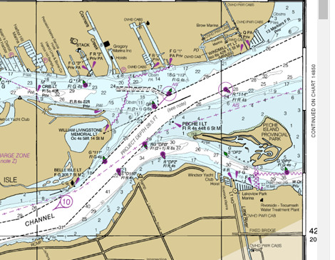

Approximate location of starting area

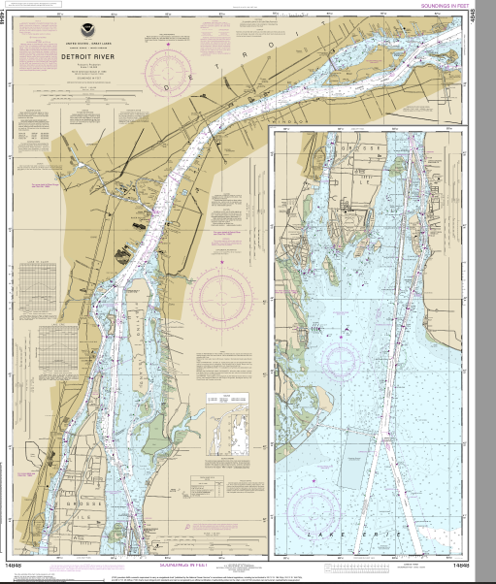

* 1. The race will take place in the Detroit River, starting in front of Windsor Yacht Club and proceeding to Grosse Ile Yacht Club. See the Sailing Instructions for more details.
  2. The course will utilize private and fixed Government marks in the Detroit River.
  3. Race distance is XX NM.

1. **Penalty System**
   1. RRS 44.1 is changed so that the Two-Turns Penalty is replaced by the One-Turn penalty.
2. **Scoring RRS 90.3**
   1. There will be one race only.
   2. Scoring will be determined in accordance with RRS Appendix A. Time allowances for boats will be calculated, Time on Distance, in accordance with the boat’s PHRF Lake Erie Rating.
3. **Radio Communication**
   1. Courtesy broadcasts by the R.C. will be on VHF Channel 71.
4. **Classes to Race**
   1. Classes may include Jib and Main (JAM), Spinnaker, & Cruising
   2. A minimum of 3 entries are required per class.
   3. Each class will be subdivided based on PHRF handicaps and the number of competitors registered. A scratch sheet with class subdivisions will be published on the Notice of Race website on or before 09:00 on July 27th.
   4. A One Design class may be added if there are at least 5 entrants.
5. **Prizes**
   1. Flags will be awarded at the GIYC Awards Night in the fall. Multiple trophies will be announced at the afterglow.
6. **Disclaimer of Liability**
   1. RRS 3 states: ‘The responsibility for a boat’s decision to participate in a race or to continue to race is hers alone.’ By participating in this event each competitor agrees and acknowledges that sailing is a potentially dangerous activity with inherent risks. These risks include strong winds and rough seas, sudden changes in weather, failure of equipment, boat handling errors, poor seamanship by other boats, loss of balance on an unstable platform and fatigue resulting in increased risk of injury.  **Inherent in the sport of sailing is the risk of permanent, catastrophic injury or death by drowning, trauma, hypothermia or other causes.**
7. **Insurance**
   1. Each participating boat shall be insured with valid third-party liability insurance with a minimum cover of $300,000 per incident or the equivalent.
8. **Further Information**
   1. For further information please contact: Michael Fluegemann, 734-751-5513, [race@giyc.com](mailto:race@giyc.com)